Cattle Herd

Introduction

Cattle are modelled in FASSET using a dynamic energy, C and N flow model that operates on a daily basis. The description of energy within the model is based on the SIMCOW model but it has been updated to reflect the latest Danish method for calculating the energy requirements of cattle. The description of N dynamics is based on the Danish system for calculating the protein requirements of cattle. In addition, models have been developed to simulate diet choice and the consumption of grazed forage.

This document describes how the structure of the cattle herd is modelled in FASSET and how cattle and grassland are managed.

Herd structure

The herd structure is defined in terms of the number of animals of a particular type that are present on the farm. For dairy farms, these are heifers, 0-0.5 years; heifers, 0.5-1 years; heifers, 1 years to first calving and mature dairy cows. For beef cattle, these are heifers, 0-0.5 years; heifers, 0.5-1 years; heifers, 1 years to first calving, suckler cows; female beef, 0-0.5 years; female beef, 0.5-1 years; female beef, >1 year; male beef, 0-0.5 years; male beef, 0.5-1 years and male beef, >1 year.

Technical specification

The FASSET cattle module currently simulates individual animals. The characteristics of each animal are defined in animals.dat (see Appendix 1). These characteristics define the mature weight of the animal and the parameters of the lactation curve.

The structure of both the dairy and beef herd is handled in the dairystock class (in dairystk.cpp). Within the dairystock class there is a linklist called grouplist which contains instances of the class cattleGroup (cattlegrp.cpp). The instances of cattleGroup each contain a linklist called group that contains pointers to instances of the cattle class (cattle.cpp). It is important to note that it is the dairystock/cattleGroup constellation that maintains the herd structure by buying/selling animals or promoting them from one group to another, owns the instances of the cattle and is responsible for ensuring that the daily servicing of the cattle functions is performed; other FASSET classes can store pointers to one or more instances of the cattle class but cannot instantiate or delete instances.

FASSET can simulate two types of cattle herd; dairy and beef. The two types of herd are held in instances of dairystock which have the predefined names Dairystock and Beefstock. The herd structure within these two categories is defined in the text file livestock.dat. The rules for definition of the herd structure are that:
- The animal groups are numbered sequentially, starting with 0.
- The first group starts at age 0.
- The minimum age of the ith group is the same as the maximum age of the i-1 th group.

An example is shown in figure 1.

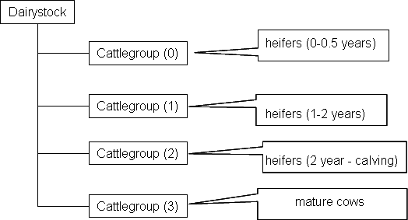

Figure 1 Example of herd structure for dairy animals.

The number of animals within each group is defined on an annual basis in cattle.fnn, where nn = 0 to the maximum number of years simulated -1. Animals are initially assigned to a group. When an animal reaches the maximum age specified for the group, it is either promoted to the next group in the series (if there is space) or is sold. Similarly, when a calf is born, it is either allocated to the youngest group (if there is space) or is sold immediately. When an animal reaches the maximum age of the oldest animal group (e.g. Cattlegroup (3) in Fig 1), the animal is sold. If an animal in the ith group is sold or promoted to the i+1th group and a replacement animal is not promoted from the i-1th group, a new animal is purchased. This animal has the same characteristics as the one that is promoted or sold but has an age equal to the minimum age for the group. The weight of the animal purchased is adjusted to reflect that age.

A full list of the cattle categories is shown in the following table.

Table 1 List of possible cattle categories
Group No. | Category | Name in file  (Alias)
0 | Heifers aged 0-0.5 years | HEIFERS1
1 | Heifers aged 0.5-1.0 years | HEIFERS2
2 | Heifers aged 1.0 years – first calving | HEIFERS3
3 | Dairy cows | DAIRY
4 | Suckler cows | SUCKLER
5 | Female beef calves, age 0-0.5 years | FBEEF1
6 | Female beef calves, age 0.5-1.0 years | FBEEF2
7 | Female beef calves, age 1.0 years to calving | FBEEF3
8 | Male beef calves, age 0-0.5 years | MBEEF1
9 | Male beef calves, age 0.5-1.0 years | MBEEF2
10 | Male beef calves, age 1.0 years to slaughter | MBEEF3

Note that beef and dairy animals are simulated with the same animal model. The difference between the two types of animals lies in the (optional) difference in herd structure and feeding and in the weaning of dairy calves at birth.

The dairystock class contains functions that on start-up seed the herd with animals. The animals are created so that they are evenly distributed age-wise over the range of the cattle group. The dairystock class contains the DailyUpdate function that is called on a daily basis. This calls the corresponding function in the cattle class and also calls functions within dairystock (and cattlegroup) that check to see if any animals have aged beyond their maximum limit. If so, they are promoted into the next age group (if there is space) or sold, and replacement animals are bought.

